Hello There, Thanks for your help ☺

Please evaluation these given results of 14 images each of which have been searched by 6 different algorithms

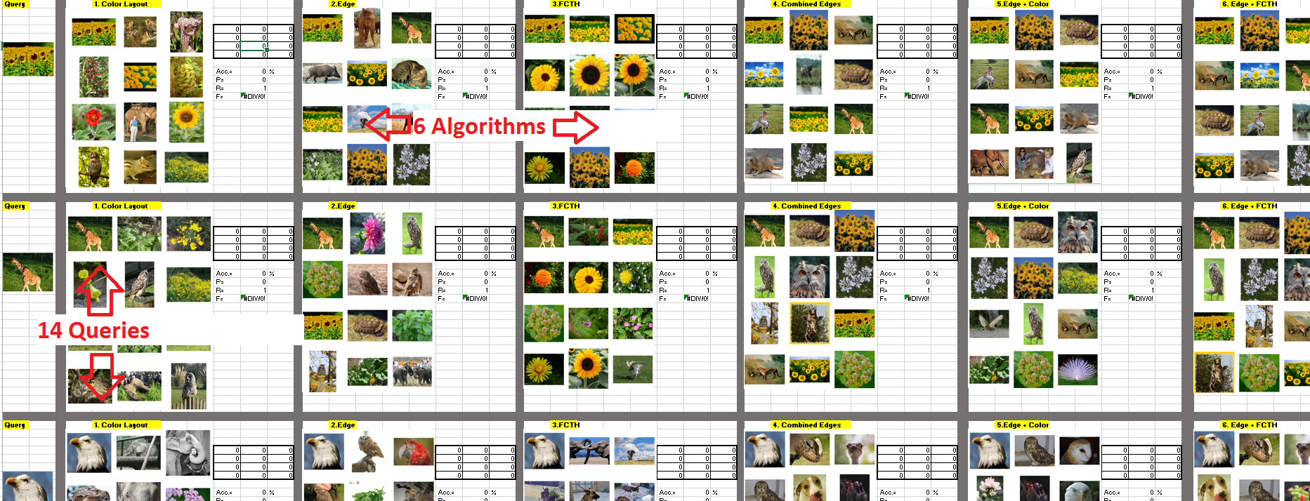

The small matrix 4x3 shall be filled by values from [0, 1], like for example the matrix bounded by the red rectangle, **this presents how similar the query image to the corresponding output:**

* If you decided to put 1 this means the desired output image is really near the query
* And if you decided to put 0 this means it is completely far from the query.

*NOTE: please fill your own matrices, from you POV and DON’t copy and paste this matrix*

